SREENA PROJECT REPORT

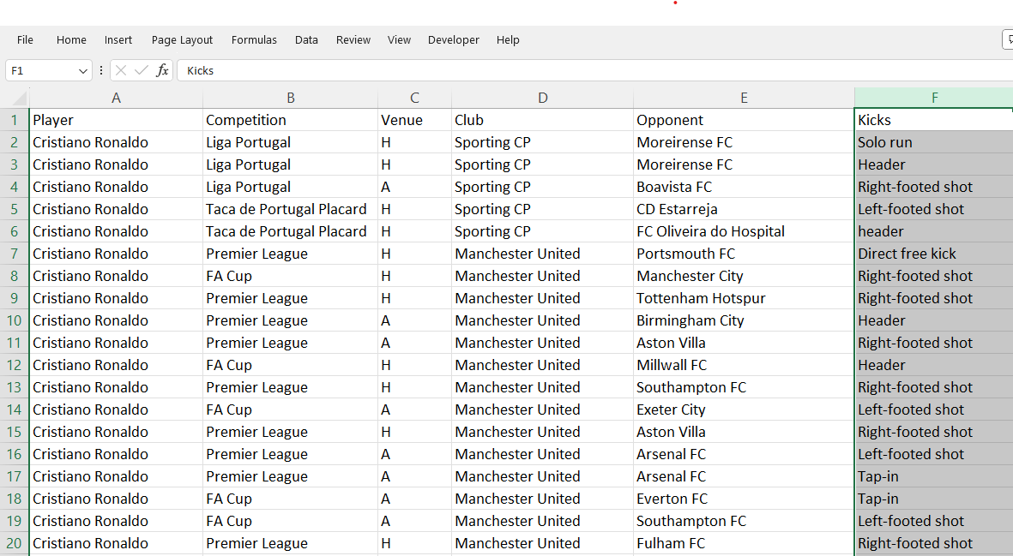

**Data Dictionary:**

**Player:** The name of the football player (either Cristiano Ronaldo or Messi).

Competition: The name of the competition in which the match was played (e.g., UEFA Champions League, La Liga).

**Venue:** The location where the match took place.

**Club:** The football club for which the player was playing during the match.

**Opponent:** The name of the opposing team.

**Kicks:** The number of kicks attempted by the player during the match.

**Notes:**

**Player:** This column specifies either "Cristiano Ronaldo" or "Messi" indicating the player involved in the match.

**Competition:** This column contains the name of the competition such as "UEFA Champions League", "La Liga", "FIFA World Cup", etc.

**Venue:** Indicates the location where the match was held.

**Club:** Specifies the football club the player was representing during the match.

**Opponent:** The name of the opposing team.

**Kicks:** The number of kicks attempted by the player during the match.